5th Grade Supplies

Full-size Book Bag

Headphones or Ear Buds (no wireless)  
Two 2’’ Binders 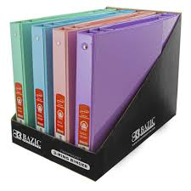

Four 2-Pocket Portfolio Folders with 3-holes 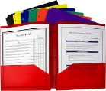

Four packs of wide-ruled loose leaf Paper

Two Composition Notebooks (journals) 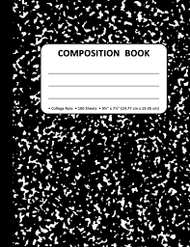

One pack of Sheet Protectors

Three packs of 3 x 5 Index Cards

Pencil Bag that contains:

* Pack of Pencils
* Scissors
* 4 glue sticks
* Pack of Highlighters
* Markers
* Crayons

Wish List: Feel free to send in tissue, hand sanitizer, zip-loc bags (sandwich and gallon), and paper towels. Our classroom always needs these things!